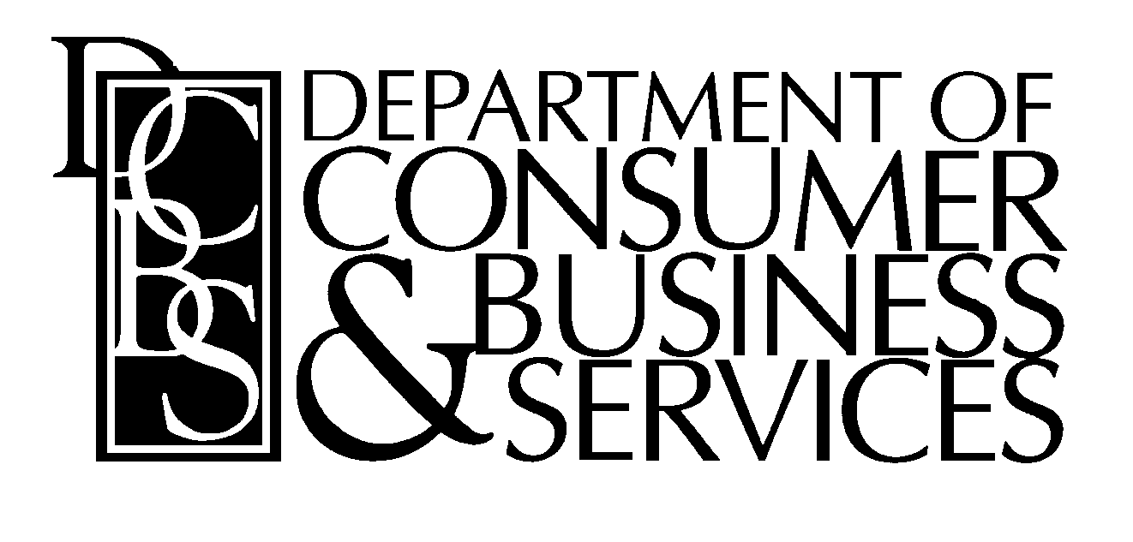Division of Financial Regulation MEMORANDUM
May 24, 2016
To: Roger Helbling, Executive Director of the Surplus Lines Association

From: Ryan Keeling, Gail McFarlin (DCBS, Division of Financial Regulation, Insurance Institutions)

Subject: Surplus Lines Insurance “Diligent Search Form”
(Surplus Lines Association is referred to as SLA)

DILIGENT SEARCH FORM

(as copied from the SLA website ( http://www.oregonsla.org/resources/forms)
ORS (Oregon Revised Statutes) 735.425 Filing by licensee after placement of surplus lines insurance. (1) states: ""Within 90 days after the placing of any surplus lines insurance in this state, each surplus lines licensee shall file with the Director of the Department of Consumer and Business Services ..."" (b) ""A statement on a standardized form furnished by the director, as to the diligent efforts by the producing agent to place the coverage with admitted insurers and the results thereof. The statement shall be signed by the producing (retail) agent ...""

Per the SLA the uploading of this form into the SLA’s current software has formatting issues and causes a severe bottleneck in the timely processing of electronically submitted forms. This memo is to inform you that we agree with your request to allow the producers and agents who must first collect these completed and signed forms may designate in some way agreeable with the SLA that they do, indeed, have the completed and signed forms on site at there places of business and will retain these records no less than five years following contract termination according to ORS 735.460(2). They no longer are required to electronically upload them into the SLA’s software. The forms may be reviewed at the discretion of the Director of the Department of Consumer and Business Services.

